Network Task

Task Description:

1.Get me the IP address of a particular domain (guvi.in). How do I find my CPU/memory usage of my server?. Test the connectivity between 2 nodes?

2.I have deployed an application in guvi.com:9000, and logs show my app is running, but I’m unable to view the page. Check whether my port is open or not ?

Techstacks needs to be used :

- Shell (AWS, Gitbash)

Task1:
- Use the nslookup command for a straightforward DNS query.
nslookup guvi.in

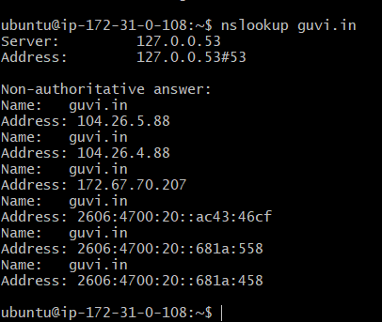

- You can find the CPU memory usage using command TOP/ HTOP
Command: top
top

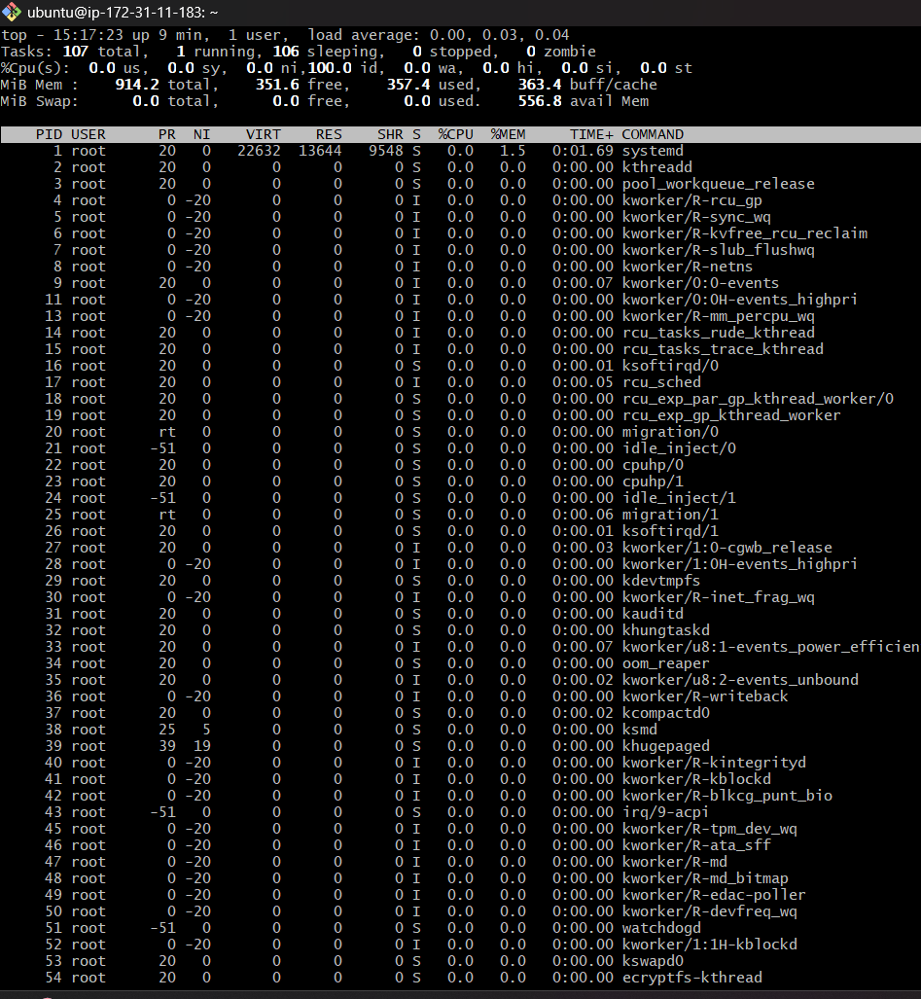

Command: Htop (for human readable form)
htop

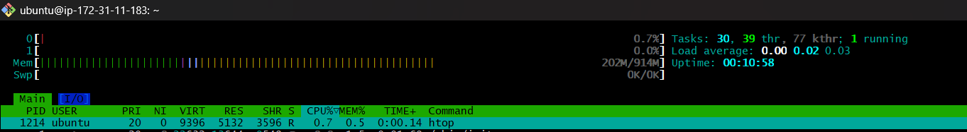

- You can test the connectivity by the pinging the domain or ip address
Command: ping guvi.in

Ping guvi.in
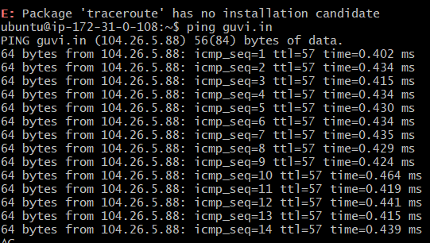

Task2:
Use command : telnet guvi.com 9000

Telnet guvi.com 9000

